https://www.fws.gov/midwest/endangered/lists/ohio-cty.html

Ohio

County Distribution of Federally-Listed Endangered, Threatened, and Proposed Species
Download PDF <This link doesn’t have pictures but is a working link. The links in the chart below don’t work, but the website is listed at the top of the page. I included pictures at the end of document for reference, however, using the actual website, there is a wealth of information on each.

For more information about threatened and endangered species in Ohio,
contact the U.S. Fish & Wildlife Service office at 4625 Morse Road, Suite 104 Columbus, Ohio 43230 (614-416-8993)

Bald Eagle
Bald eagles are no longer protected under the federal Endangered Species Act and Section 7 consultation with the U.S. Fish and Wildlife Service is no longer necessary. However, the bald eagle remains protected under the Bald and Golden Eagle Protection Act.
Information about Bald Eagles
Information about Eagle Permits and the Bald and Golden Eagle Protection Act

Revised January 29, 2018
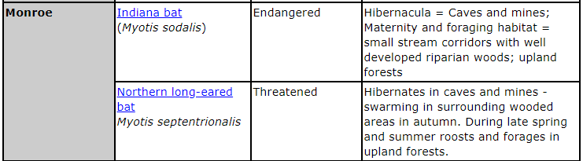
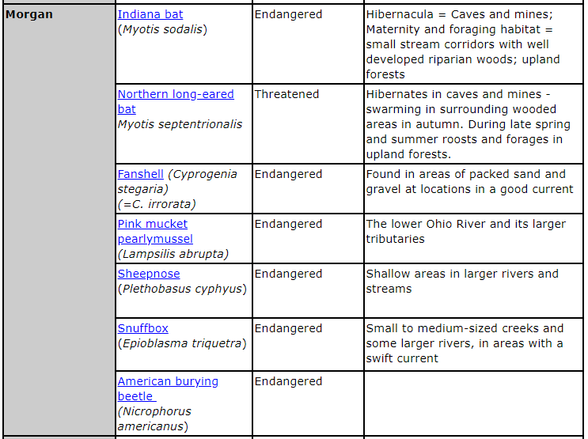
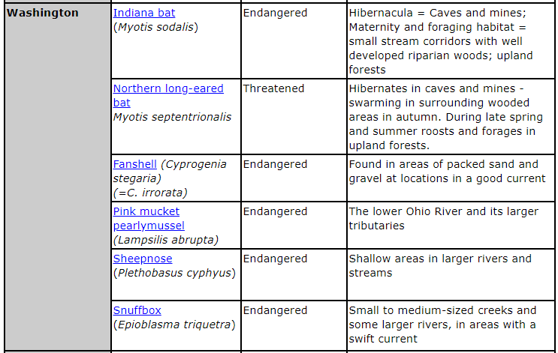

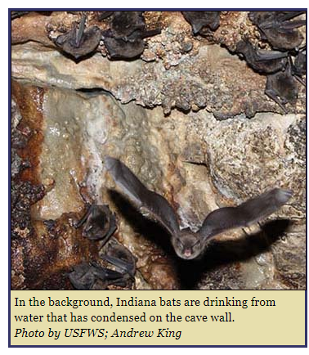 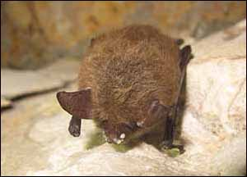 Northern long-eared bat with symptoms of white-nose syndrome.
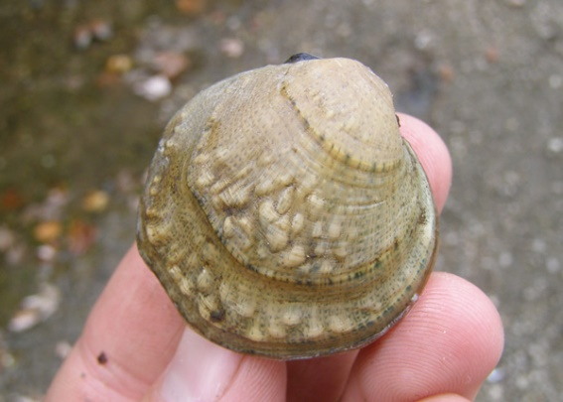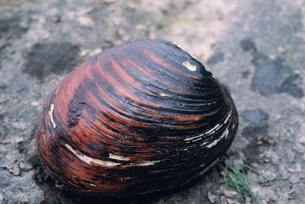
Fanshell. Pink mucket (pearlymussel) (Lampsilis abrupta)

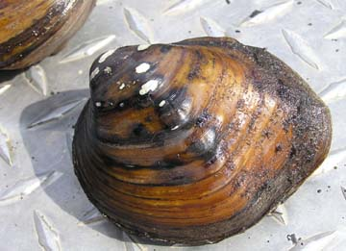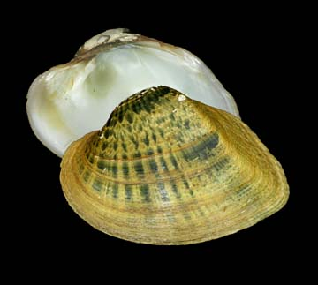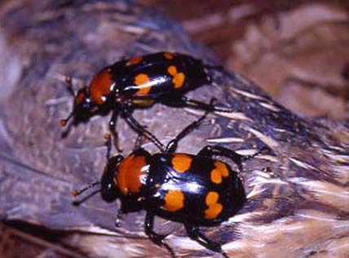
Sheepnose, snuffbox mussel, American burying beetle (Nicrophorus americanus)

